**DEVELOPMENT OF NSTP SYSTEM FOR TECHNOLOGICAL UNIVERSITY OF THE PHILIPPINES - CAVITE CAMPUS**

**A RESEARCH PROJECT**

Presented to the Faculty of

**Department of Industrial and Technology**

Technological University of the Philippines - Cavite Campus

Carlos Q. Trinidad Avenue, Salawag, Dasmariñas City, Cavite

By

**Ala, John Christopher D.**

**Jumalon, Jhousua C.**

**Manuel, Leomhar**

**Rapal, Christian C.**

**Seña, Renshi Angelo G.**

In Partial Fulfillment of the Requirements for the Degree

**Bachelor of Engineering Technology**

**Major in Computer Engineering Technology**

**May 2022**

**Chapter 1**

**INTRODUCTION**

**Background of the study**

The evolution of Technology nowadays increasingly has a higher impact on users worldwide. Computer Technology is a basic necessity in modern everyday life. It has made most daily activities more accessible, faster, and more accurate. It is also used for communicating or even from the other sectors that use computers with internet connectivity. People can access different websites anytime, like Facebook, that most of us or even children can access. It serves as a tool for communication across the globe. It simply makes the world smaller. Websites are intended to provide rich information and quality service. It acts as a connecting line between diverse individuals across the globe. It is mixed in many ways depending on the website's content as an internet tool.

Having a computerized system in an organization makes the tasks easy because it will help to access data in a shorter period, unlike the manual form that can duplicate errors in the part of the concerns. There is an urgent need for it since the number of members is rising, and the manual process of managing student records and schedule of events is no longer being practiced. This study aims to provide the organization and member’s convenience and quality management of data that would replace the manual transaction of the registration.

The researchers encountered many problems inside the organization in a few short years. Number one is the lack of systematic processes to handle the student's data correctly. Some cause of this is the old method of encoding data using Microsoft Excel and other Microsoft apps. The second problem is the Print form method of enrollment which is not good because there is a large population of students taking NSTP. The method leads the working place of the NSTP to a messy environment because there are a bunch of papers containing data from the students, which will be encoded manually by the designated officers of the Unit. It can also be lost at all times, and if this ever happens, there is no other backup to restore. The next problem is the Slow making of certificates. Making certificates is done manually or one by one by typing each student's name on the provided template. Additionally, they came up with an idea to develop an application or website that would cover and solve all problems.

This project aims to change the traditionally manual process of the NSTP Organization to lessen the time and effort they use on every work they have. And also it can help the students to reduce their effort on registration and locating their information like grades, Platoons/Sections, and other Related files of their field.

**Objectives of the Study**

The overall goal of this project is to develop a web-based system for TUPC NSTP that can Keep all the student’s personal information, make transactions with the Organization for all NSTP Students, and replace the outdated technique of handling documents inside the department.

1. Design a Web-based system that can replace the old and unorganized method of keeping/ archiving students' data and records inside the NSTP Department.

1.1. Make it easy to find records, including records of the students.

1. It reduces the time every student consumes by manually filling up forms during enrollment.

2.1. By digitizing the forms using the system so they can answer them easily

1. To develop an NSTP System that contains the following features.

3.1. A system that allows for online enrollment and securely and neatly organizes students' data and other personal information.

3.2. A system that can generate certificates for all students who took NSTP.

3.3. A system where staff can upload files or other lecture materials for the student to download.

3.4. A system that can be browsed in any device such as mobile phones, tablets, and pc.

3.5. A system that makes it simple for all past students, alums, and staff to locate records when needed.

3.6. A system with a companion mobile application which allows instructors to track attendance with a merit/demerit system using a student’s QR code.

3.7 A system that allows for the importing and exporting of data records inside a database structured in a .csv file format.

**D. Scope and Limitations**

The central concept of this study was based on the traditional way of transactions in the NSTP Department.This study focuses on the innovation of the conventional method of making transactions like the handwritten filling of students on the enrollment form, manual encoding of students' data on Microsoft Excel and other Microsoft platforms, manual typing of students' names on provided certificate template during certificate issuing, handwritten student attendance on a sheet of paper and also the manual sectioning or sorting of students. The researchers aimed to improve the traditional way of all transactions in the NSTP Department. This is to reduce the time of every student who manually fills out all forms needed and the NSTP staff working inside the organization. This study was intended to provide a more organized and precise system that can give good service to the students and staff of the organization.

For the development and implementation of this study, university students can now enroll online, see their section or platoons online, and request documents online without any interruptions. The faculty and staff can work efficiently on this system. They can communicate with the students online and quickly access all the data and information of the students. Admins and coordinators can also take students' attendance by using this application that can see all student lists and take attendance by simply checking the checkbox inside the said Web Application or by using its companion mobile application’s attendance tracking feature by scanning a student’s QR code to verify their attendance.

The study was only limited to the school premises. The beneficiary of this study is the NSTP Department of the Technological University of the Philippines and the students of the said university who take the NSTP unit yearly. The students are required to submit a copy of their Certificate of Registration (COR) upon registration to the NSTP system as part of the validation process.

**E. Significance of the Study**

The study expects that this will be useful and can give a contribution to some parties, as follow:

For the ROTC officer and CWTS facilitator, they can use this Web App to reach out to students on many things, such as announcements about ROTC / CWTS meetings, uploading files of their lessons, and tracking their records such as attendance time of when the students enter and exit the premises.

Students can quickly know when and where the meeting is, so they don't have to worry about missing it. When it comes to attendance, thanks to this application, attendance is faster and easier by simply clicking the checkbox in the application.

For TUPC alumnus, If they return or want to become a reservist in ROTC, they will still be able to see the necessary information regarding their Nstp records, such as their grades, course, and other data during their stay on the school campus.

**Chapter 2**

**CONCEPTUAL FRAMEWORK**

This chapter presents the review of relevant literature and studies that the researchers found the importance of using web applications to manage students' data, mobile view for students without a personal computer, and online certificate generator. It also provides the research's conceptual model and the required information for the materials or software used in developing the prototype. Lastly, the definition of terms to fully comprehend the research.

**Review of Related Literature and Studies**

**Web Application**

A web application (or web app) is software that runs on the internet browser instead of software programs that run locally and natively on the device's operating system (OS). Web applications are delivered via the World Wide Web to users who have an active network connection.

According to Indeed Editorial Team (2020), A web application is a client-server program. It means that it has a client-side and a server side. The term "client" refers to the program used by the individual to run the application. It is a component of the client-server environment in which multiple computers share information. In the case of a database, for example, the client is the program through which the user enters data. The server is the program that stores the data. They helped the Nstp system to provide the students with a useful application that makes their registration in the Nstp course, generating of certificates, and the record of their attendance so that the Nstp coordinator can easily record their attendance, including the time they are in and out of the field.

**Mobile Application**

A mobile application is a software application that is designed to run on a mobile device, specifically for the use of an instructor or a student. Mobile applications often stand in contrast to desktop applications which are designed to run on desktop computers, and web applications which run in mobile web browsers rather than directly on the mobile device.

NSTP system has a companion mobile application for instructors to track attendance using a student’s QR code with a merit/demerit system for a certain training day.

**Online Student Enrollment**

The online Enrollment System also includes multiple notification techniques such as SMS and email. The business rules are stored in XML, which allows the system interface to be portable to a broader range of devices, such as Personal Device Assistants (PDA) (Then, 2006). The interface recognizes whether the user is using a PC/laptop or a device with a smaller screen, such as a PDA. In brief, the enrollment system's back-end and front-end engine work together to create a high-quality user experience.

This research conducts the student's enrollment workflow from the online enrollment of the Nstp to the approval workflow. Students can enroll in their topics before the start of their semesters using the Nstp system. This research allows students from outlying areas to register over the internet rather than visiting the university and also includes business regulations.

**Certificate Generator**

The usage of computer software is widespread. Several organizations perform their daily activities more efficiently using applications founded on computer science knowledge. Certificate Generation Systems can be used in various Universities that are planning to automate the distribution of digitally verifiable marks sheets of students to ease the work. This system verifies the participants' information from the access database and generates the participants' certificates in a portable document format (Bharti Chikankar, Sidhant Jaiswal, 2020).

Nstp System can generate a certificate automatically. Unlike the old way, which involved manually creating certificates and typing the student's name into the credentials. However, in this research, it used an automatic certificate generator. We can quickly generate student certificates faster than the previous way, and also, the department staff will lessen the time and effort used on creating certificates.

**Dynamic HyperText Markup Language (DHTML)**

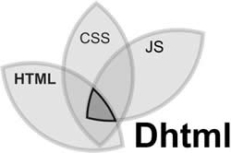

*Figure 3*. DHTML

*http://www.differencebetween.info/difference-between-dhtml-and-html5*

According to a website for educators, DHTML stands for Dynamic HTML and should not be confused with HTML. Netscape Navigator and Internet Explorer versions greater than 4.0 are examples of browsers that support dynamic HTML. DHTML is based on HTML and uses javascript, CSS, and DOM (Document Object Model, which is used to access individual documents) on document elements to help create dynamic content. It is built with HTML, CSS, JS, and DOM. DHTML employs a Dynamic object model to make changes to settings, properties, and methods. It also utilizes scripting and is linked to previous computing trends.

**Html**



*Figure 4*. HTML

[*https://play.google.com/store/apps/details?id=in.vineetsirohi.htmlreader&hl=en_US&gl=US*](https://play.google.com/store/apps/details?id=in.vineetsirohi.htmlreader&hl=en_US&gl=US)

According to Hayes (2020), HyperText Markup Language (HTML) is a collection of markup symbols or codes embedded in a file designed for Internet display. The markup tells web browsers how to render text and images on a page. He also mentioned HyperText Markup Language, a computer language used to build websites. Like any other language, the language has code words and syntax, is relatively simple to understand, and, as time passes, becomes more potent in terms of what it allows someone to create. Under the guise of the World Wide Web Consortium, HTML is evolving to meet the Internet's demands and requirements.

HTML, or Hypertext Markup Language, is used by researchers to create the NSTP system website pages. The researchers use HTML to generate text titles and headings, organize illustrations on a site page, connect to different pages within site and connect to multiple locations.

**CSS**



*Figure 5*. Css

[*https://1000logos.net/css-logo/*](https://1000logos.net/css-logo/)

CSS stands for "Cascading Style Sheet," it is used to format the layout of Web pages. They can use them to specify text styles, table sizes, and other Web page elements that were previously only identified in the HTML of the page. CSS enables Web designers to create a unified look across multiple website pages. Rather than defining the style of each table and block of text within a page's HTML, commonly used techniques should be described only once in a CSS document. After it is defined in the cascading style sheet, the set can be used by any page that links to the CSS file. CSS also makes it simple to change the styles of multiple pages at the same time.

CSS controls how HTML elements appear on screen or in other media. CSS saves a significant amount of time. Researchers used it to control the layout of multiple web pages at the same time. CSS is required for this study because it defines table cell padding around images and other objects and the border style, thickness, and color of a table.

**JavaScript**



*Figure 6*. JS

*https://1000logos.net/javascript-logo/*

According to Merida (2021), JavaScript is a dynamic programming language used for web development, web applications, game creation, and a variety of other things. It allows you to add dynamic website features that would be impossible to implement using only HTML and CSS. Several browsers include JavaScript as a scripting language for performing active tasks on the web. To name a few, you'll notice the advantages of JavaScript whenever you see a click-to-show dropdown menu, extra content added to a page, or dynamically changing element colors on a website.

**Python Web Framework**

According to Habib (2016), numerous Python frameworks make it much easier to create web applications. These frameworks combine the modules and packages that allow you to quickly build applications without having to deal with complicated Sockets and protocols in one place. On the server, modern Web frameworks are used, and some are starting to use them on the client, including code that allows them to run the client (e.g., Skulpt or Trinket). Python frameworks are frequently classified as full-stack or non-full-stack. Full-stack frameworks assist developers in creating applications from the ground-up interface to the database. Non-full-stack frameworks deal with anything less than full development.

**Django**



*Figure 7*. Django

[*https://destatic.blob.core.windows.net/images/django-logo.png*](https://destatic.blob.core.windows.net/images/django-logo.png)

Django is a web framework written by Python with a high level of abstraction that makes it simple to develop secure and maintainable websites quickly. By handling a lot of the complexity involved with web development, Django, which seasoned programmers developed, frees you up to focus on creating your app instead of having to reinvent the wheel.

Django, an open-source, high-level Python web framework, enables rapid web development and design. For this investigation, the researcher employed Django as a Python web platform. This aids researchers in avoiding common security errors. Thanks to the user authentication mechanism of this framework, which provides a safe method to manage user accounts and passwords, a web application may go from conception to launch in a couple of hours.

**XAMPP**

**

*Figure 8*. Xampp

*https://cdn.freelogovectors.net/wp-content/uploads/2021/02/xampp-logo-freelogovec*

*Tors.net_.png*

XAMPP is an acronym for Cross-Platform, Apache, MySQL, PHP, and Perl. The Apachefriends stated that it is an open-source web solution package that includes Apache distribution for many servers and command-line executables, as well as modules such as Apache server, MariaDB, PHP, and Perl.

A platform that provides a suitable environment for testing and verifying Nstp system functionality. XAMPP helps a local host or server to test its website and clients via computers and laptops before releasing it to the central server.

**Database Software Program**

A database is a logically organized collection of information or data stored electronically in a computer system. A database management system usually manages a database (DBMS). The data, the DBMS, and the associated applications are referred to collectively as a database system, frequently abbreviated to the database.

A software program for storing the data is gathered in this study. Every query in the Nstp system was recorded here, including students' registration data, attendance (when they were in and out of the field), and the records of all Nstp students, including alumni.

**Conceptual Model of the Study**

This study's conceptual model included a design thinking methodology that provided a solution-based approach to problem-solving. A design thinking model was used to solve complex problems that arise in our environment. Figure 8 shows the stages of design thought.

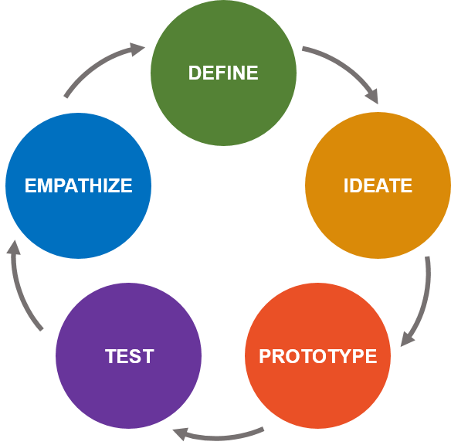

*Figure 9.* Design Thinking Model

[*https://www.lc-global-us.com/hubfs/Design_Thinking_Meets_Systems_Thinking_---_Johne_Reaves_-_LC_GLOBAL_Consulting_Inc_-_Change_and_Innovation_Firm_New_York_NY_2016.png*](https://www.lc-global-us.com/hubfs/Design_Thinking_Meets_Systems_Thinking_---_Johne_Reaves_-_LC_GLOBAL_Consulting_Inc_-_Change_and_Innovation_Firm_New_York_NY_2016.png)

To conduct research, the researchers devised a problem in the empathize stage. They spent time observing the Nstp on how the management in the Nstp of TUPC registers students, conducts each student's attendance, and how the Nstp coordinator organizes student certification. Taking the student's attendance took a lot of time due to the excessive number of students. As a result, too much time was consumed and wasted in the process that happens just getting their attendance. Based on their observations, students confirmed their attendance by writing their names and sections on paper.

The define stage came next, which addressed the initial solution to be implemented based on the problem's cause and effect. Additionally, they wanted to propose a solution that took students' attendance using a Web Application to save time and eliminate the traditional method, which required students to write their names and sections on a piece of paper.

Using an automated certificate generator generates a certificate faster than the old method. As a result of this process, unexpected errors such as unreadable writings of the student's name, course, and other human errors may occur. As a result, many students must wait months, if not years, to obtain a copy of their certificate. This research can provide:

* A more secure process between the Nstp department and students in terms of taking attendance.
* Generating certificates.
* Obtaining the necessary data from each student.

The ideate stage was the third stage in the design thinking process. This study decided to consider the availability of Nstp departments (Rotc officers) to assist students in taking attendance, with the expectation that this solution would reduce the time students spent on the task. They created a workable solution: a Web-based Nstp system to narrow it down. The study's goal was to maximize productivity while minimizing waste. The prototype developed by the researchers was low-cost but produced excellent results.

The design thinking model's prototype stage consisted of how researchers created the prototype. They happened to gather materials or components for this study. The PC serves as the prototype's brain. Because all of the functions were connected in this component, the cellphone was used as a mobile view for browsing the Web App and taking students' attendance. Researchers intended to create a web application for creating the Nstp system and a mobile view capable of saving the data needed by the Nstp system for the project's software requirement.

The prototype was tested in the final stage, which was the test stage. The Researchers conducted a series of tests after creating the Web-based Nstp system software to see if there was an error or a problem. Researchers examined the software application's functionality, including student registration, certificate generation, and attendance accuracy. Troubleshooting procedures will be used to modify the prototype if issues or errors arise. A series of tests were repeated until no errors were found. The prototype was judged on its functionality, accuracy, reliability, speed, and usability.



*Figure 10*. Conceptual Framework

**Definition of Terms**

**Web Application** - In contrast to software applications that operate locally and natively on the device's operating system, web applications are programs that run through a web browser. The World Wide Online allows users with active networks to access web applications.

**Certificate Generator** is a fixed layout where the user manages to make a certificate multiple times; a user only needs to customize the information that will be included in the certificate.

**DHTML -** Some browser vendors refer to the mix of HTML, style sheets, and client-side scripting that enables the development of interactive and animated documents as dynamic HTML, or DHTML.

**HTML -** HTML, or HyperText Markup Language, is the standard markup language for documents intended to be displayed in a web browser. Technologies like Cascading Style Sheets and scripting languages like JavaScript can help.

**CSS -**CSS is a language used to describe the appearance of a style sheet of markup language-written documents such as HTML. CSS, like HTML and JavaScript, is essential to the Internet.

**JS -** JavaScript is a dynamic programming language for computers. It is lightweight and is most commonly used as a component of web pages, where implementations enable client-side scripts to interact with the user and create dynamic pages. It is an object-oriented programming language.

**Web Framework -** It is a software framework developed to simplify the web development process and make it easier to build a website. It includes templating capabilities that allow you to present information within a browser, provides an environment for scripting communication flows, and contains many application programming interfaces (APIs) to access underlying data resources. Most frameworks also provide tools for web developers to build a content management system (CMS) for managing digital information on websites and the Internet.

**Django -** Django is a free, open-source, Python-based model-template-views architectural pattern used in this web framework. The Django Software Foundation, an independent non-profit organization based in the United States, maintains it.

**XAMPP -**Xampp is an Apache Friends-created cross-platform web server package that includes the Apache HTTP Server, the MariaDB database, and PHP and Perl script interpreters.

**Database-** A database is a logically organized collection of structured data in a computer system. A database management system usually manages a database (DBMS).

**CHAPTER 3**

**Methodology**

This chapter contained the isometric drawings of the proposed project design, the block diagram, and the flowchart related to the process of the study. This also showed the different figures of components for the development of this project. The operation, testing, and evaluation procedures of the prototype were also included.

**Project Design**

The NSTP System was designed to help students as all as the admins and staff/facilitators of the NSTP to reduce the time they spent in NSTP task, The project website application was made using Python Django for the back-end, on the other hand the researchers used HTML, CSS, Javascript and Bootstrap as it’s front-end. The project provided with many features such as Regsitration of the student so that the NSTP facilitators will filtered if the students are physically fit to apply to their desired Platoons or components, Viewing of course materials and announcements so that the student will know if there is announcement and assignments from their Instructors, Grade computations to see their grades for the semester, Modifying of profile information just in case something changes someday.

The administration side was designed to make their work to become digitalized that will help to make the work easier, The admin Web application are provided with many features such as accepting students applications for the Platoons or components, Students profile review to see if they’re physically fit to enroll in their desired component, Making general and section announcements, setting up enrollment period as well as the setting up of registration period for the student, Assigning sections or platoons, Grading System for students to know their current standing, Certifications, Alumni search for those who are already graduated in NSTP so that they can also see their basic information regarding the time they spent in NSTP, Sending messages through system email for notifying them about NSTP matters, rendering attendance from csv file.

In addition, for the students attendance the researcher used MIT App inventor for the mobile application to take the students attendance, the main function of the NSTP mobile application are to take the students attendance and save it to csv file that will be needed to NSTP Web Application to records the attendance, regarding the security of the mobile application, in order to make it secured from unexpected user the researcher the researcher also made sigup for the staff that admin user only can access.

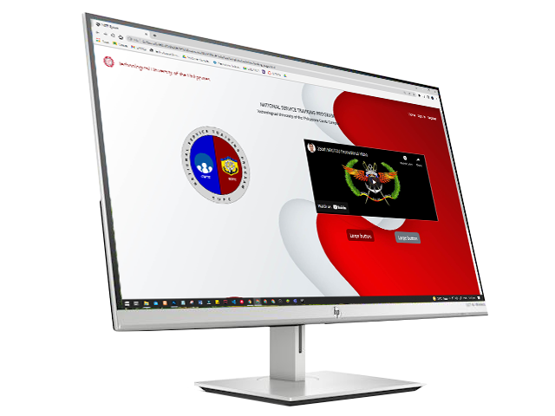

*Figure 11.* Web Application

In figure 11, it shows the interface of the proposed system (Web application). It was applicable to any computer devices and mobile phones with an internet connection. The researchers used computers as the primary medium to implement the proposed system and mobile was the secondary. The system requires the users to register to have full access to the system. Meanwhile if the one who will use is not registered yet they will be able to use the system also with the limited feature like searching their names if they have a record to the NSTP and they can also send direct email through the emailfield provided.

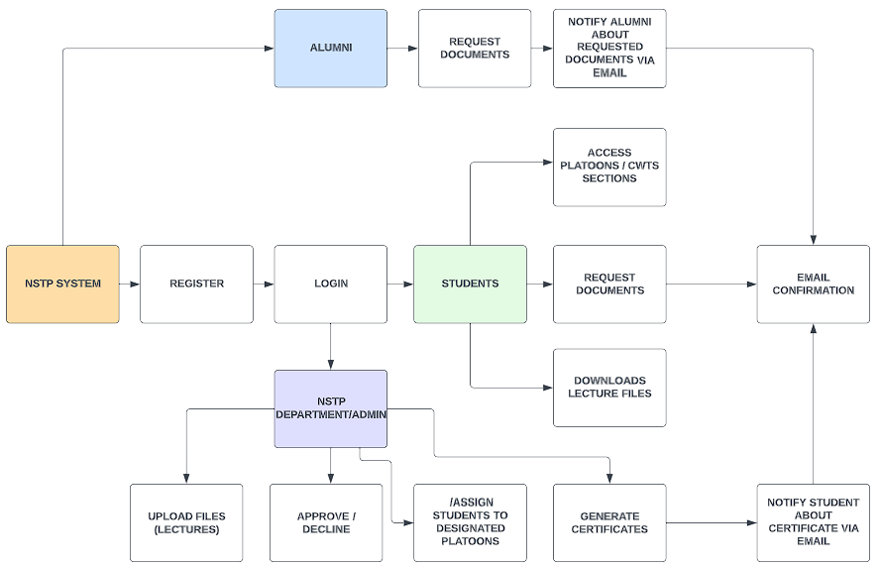

*Figure 11*. Block Diagram for Proposed System

*Figure 11* shows the block diagram of the proposed system. A block diagram is a system's representation of its main components or functions through the use of blocks connected by lines that reveal the connections between the blocks. They play a significant role in the design of hardware, electronics, software, and process flow diagrams in engineering. The starting part of the diagram was the NSTP System where all the process happens. First the users will register to create their account then continue to login. After logging in they will be able to access the system features. After they have created their account, the administrator of staff is responsible for reviewing the student's profile and they have the power to accept/decline the student’s application based on their information. Also in addition to the registration part, it is required to upload the photocopy of the Certificate of registration (COR) to be used as medium to recognized as active enrollee of the said school year. The proposed system has also a part where the staff or admin can upload the lecture files and it can be also downloaded by the students. The system has also a part of generating certificates that the students have requested and in addition is the email notification that serves as the medium of connection between students and staff of the NSTP Department.

**Lvl 1 DFD of NSTP System**

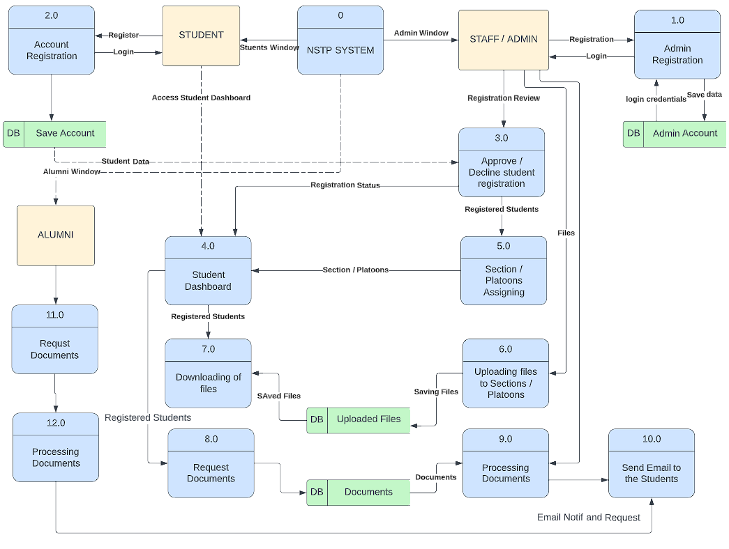

*Figure 12:* Data Flow Diagram

*Figure 12* shows the Data flow diagram of the proposed system. The students of Technological University of the Philippines-Cavite will be the users of the proposed system. The first step was the registration of the students and it will serve as their enrollment. Once the student enrollment was approved by the admin, the status of enrollment will be “APPROVED” and it will be displayed at the student’s dashboard. The user is able to login and access the NSTP System Student’s User Interface (UI). When they come to the system they will be able to do usual things like view and download files, edit their information, monitor their enrollment status and also they can request documents using the provided page inside the system. All of the students' actions inside their respective accounts also have a corresponding action from the staff or instructors who use the admin part of the system. Before the students get enrolled their information was reviewed by the staff like the photocopy of their Certificate of registration (COR) which is highly required to complete the enrollment process. The next was the Uploading of files which is also done by the Staff of the department as well as the confirmation of the document requested by the students and. Lastly is the email notifications from the NSTP Department for the students who request documents and for those who have an issue or any related problems regarding their Informations.

**Project Development**

The preliminary stage of developing the NSTP system started in the idea of innovating the old and traditional enrollment system of both component of NSTP which is ROTC and CWTS at Technological University of the Philippines Cavite Campus. One of the most visible changes in the development of the system is the appearance of the system’s User’s Interface (**UI)** , the researches do consider the importance of using the the appropriate color for the system’s User’s Interface (**UI)** , the researchers also contemplate the design that they’re applying to the system such as borders,backgrounds, images,sizes and fonts for it to look professional.

The researchers also manage to add some feature on the system,they manage to include a search page located at the landing page, where the school alumni’s can search their basic personal information such as their name and the year they graduated, but if they wanted to have an access to their full student information they can reach out the admins via email, send email option is available on the search page too.

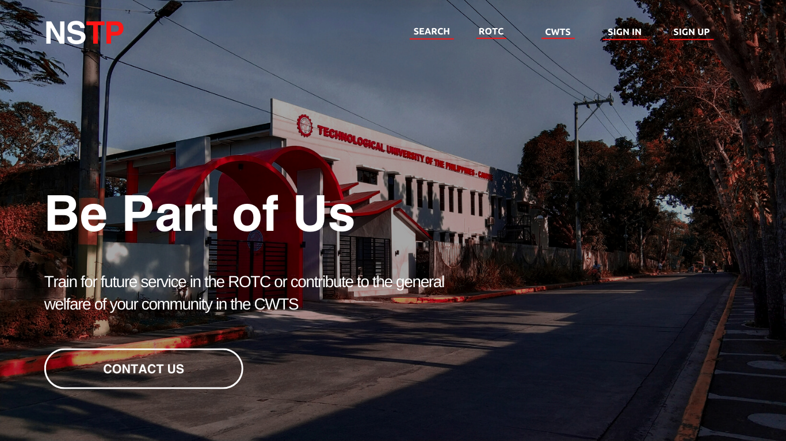

*Figure 13.* Landing Page (WireFrame Design)

Figure 3, shows the Canva design of landing page where users can search past graduates to see their basic information, ROTC to see the rotc descriptions, and CWTS to see what it is all about. Sign in to allow users to sign in to their accounts so that they can proceed to the students dashboard, and finally signup to create an account for them to sign in and assign to their designated platoons or components.

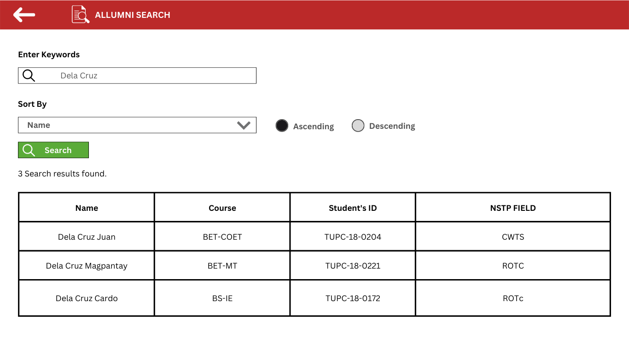

*Figure 14.* Alumni Search (WireFrame Design)

Figure14, shows the Canva design of Alumni Search, All users may access this section even if they don't have an account, and they can view the basic information about graduates.

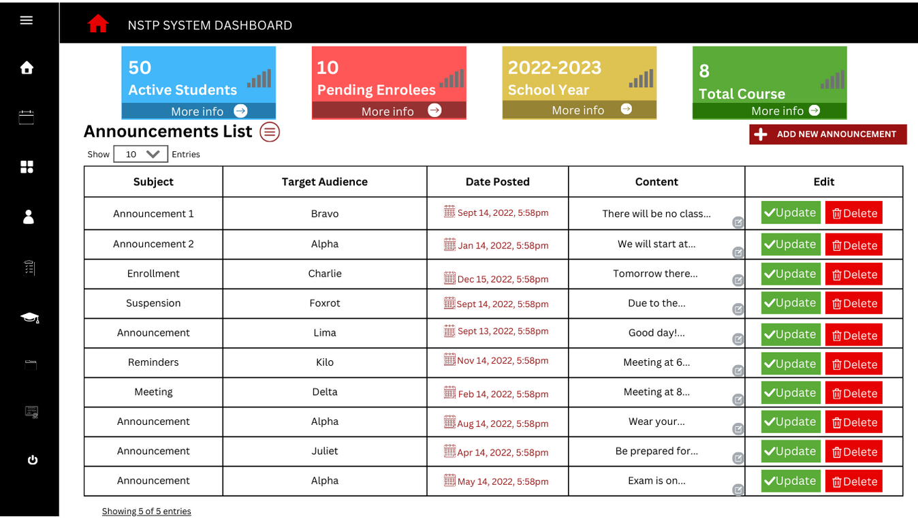

*Figure 15.* DashBoard (WireFrame Design)

Figure15, shows the Canva design of DashBoard, The administrator can submit announcements in this section, amend announcements, and delete announcements when necessary.

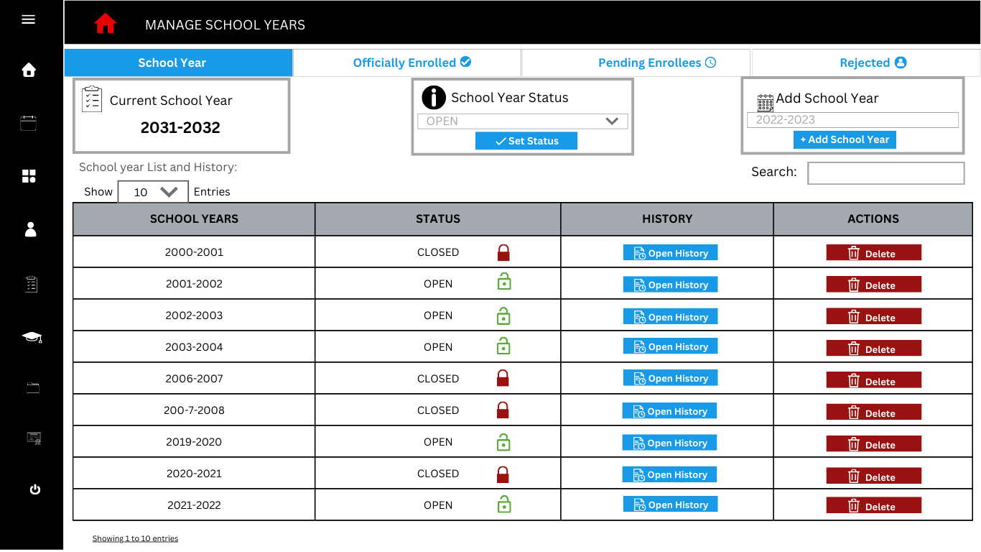

*Figure 16.* School Year page (WireFrame Design)

Figure16, shows the Canva design of Manage School Years, In this section, the administrator can activate the form and allow students to participate in the school year NSTP registration.

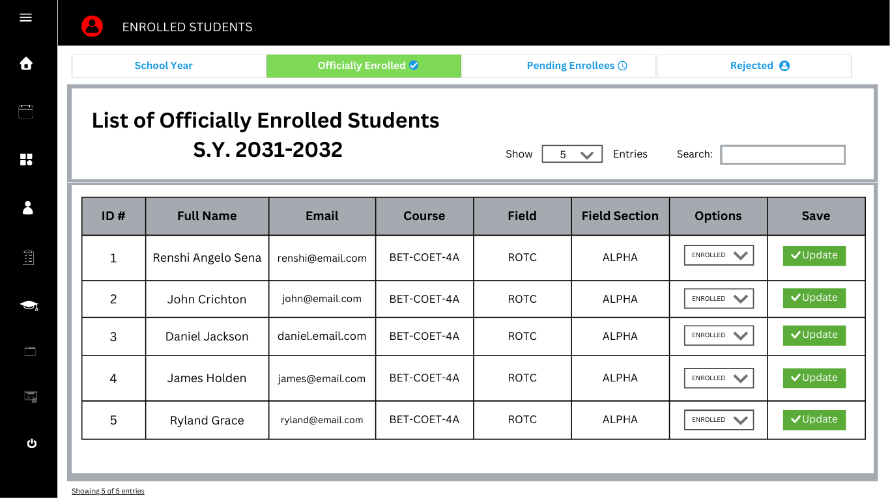

*Figure 17.* Officially Enrolled page (WireFrame Design)

Figure17, shows the Canva design of List of Officially Enrolled, The administrator may easily view all of the students enrolled in the current school year in this area. The administrator can also edit the status of the students, which can be Enrolled, Pending, or Rejected depending on the situation.

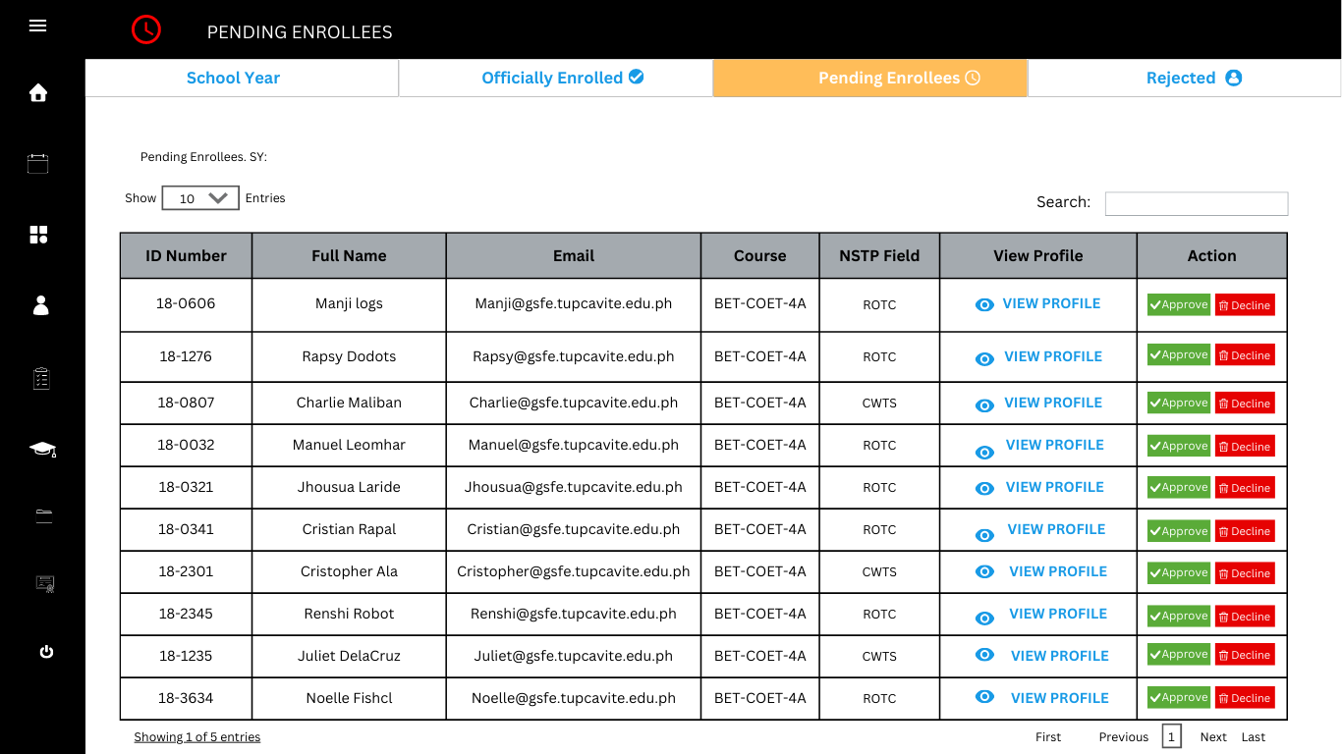

*Figure 18.* Pending Enrollees page (WireFrame Design)

Figure18, shows the Canva design of List of Pending Enrolees, In this section like in figure 17 it also shows the list of students but the main difference in this section it only show all pending enrollees.

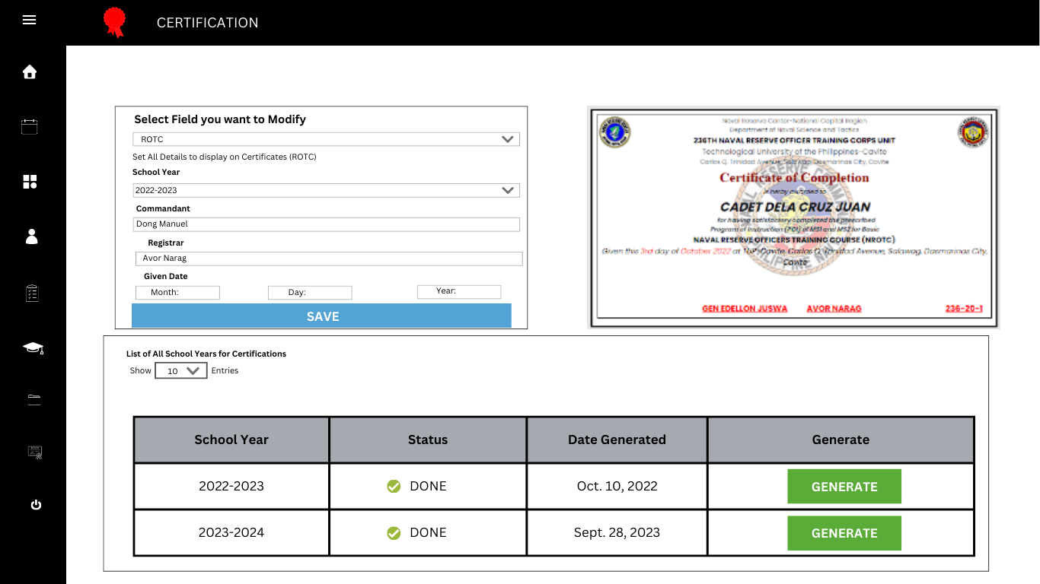

*Figure 19.* Certification (WireFrame Design)

Figure19, shows the Canva design of Certifications, The personalized certificate is displayed on this page, all students who passed will be certificated, and this certificate will be created along with their names.



*Figure 20* Landing Page

Figure 20 shows the Landing page of the Proposed System. This is the way of administration and students to access their Account by logging in.

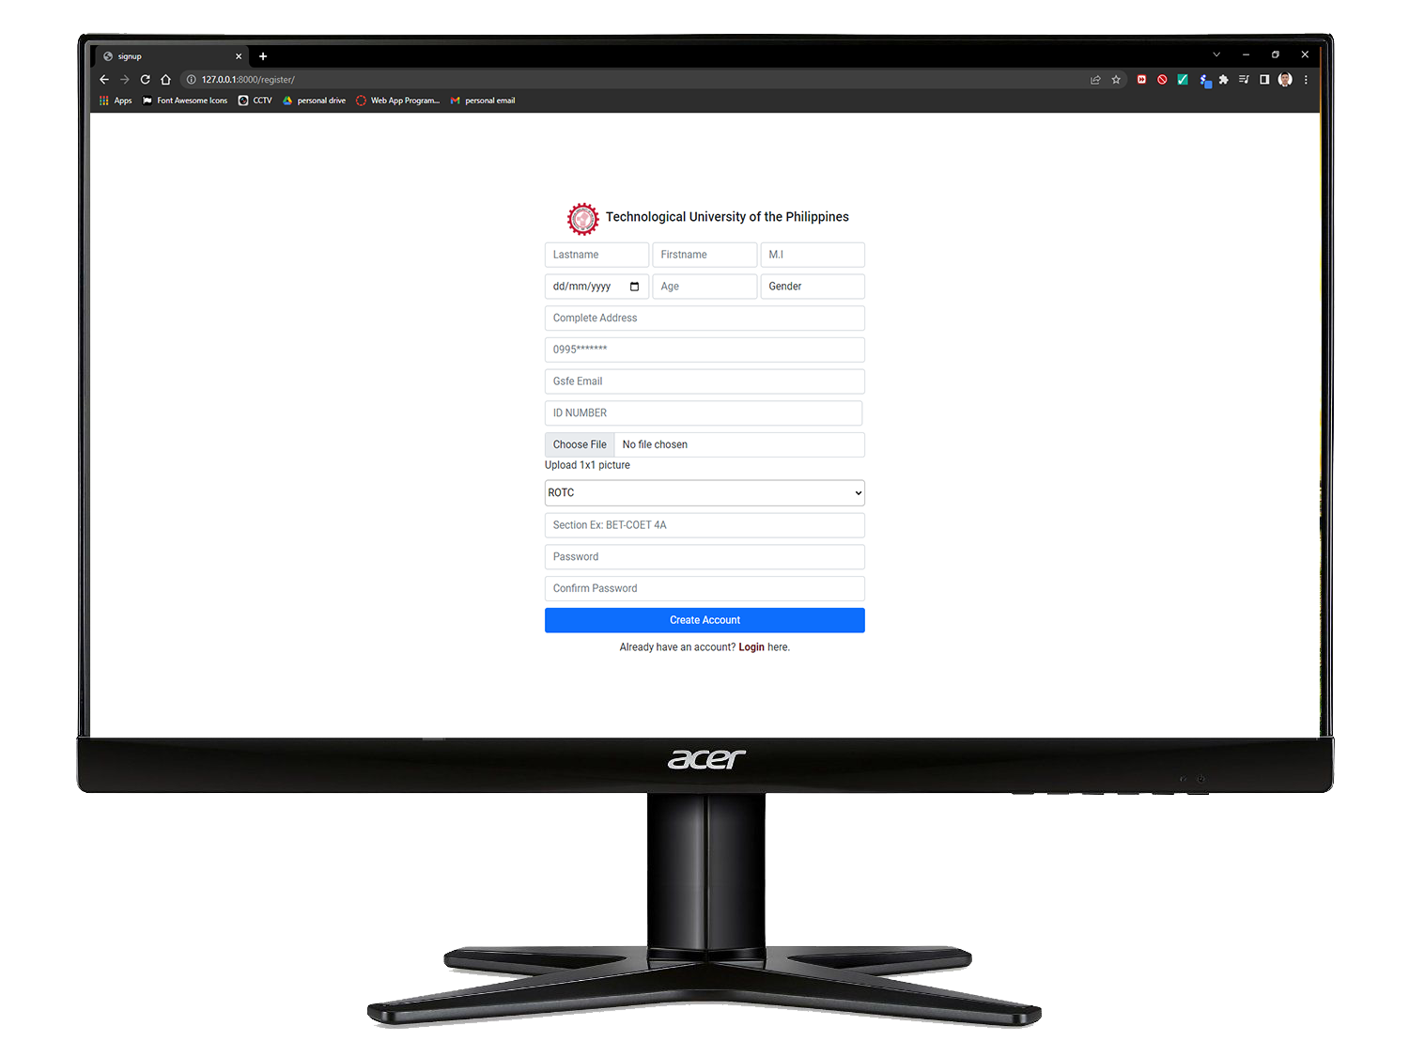

*Figure 21; User Sign Up Page*

Figure 21 shows the registration page of the system. This is the page where the students will input their information and all required data to create their account as well as to register. Once the student is registered they will be able to login and access their account on this Proposed system.

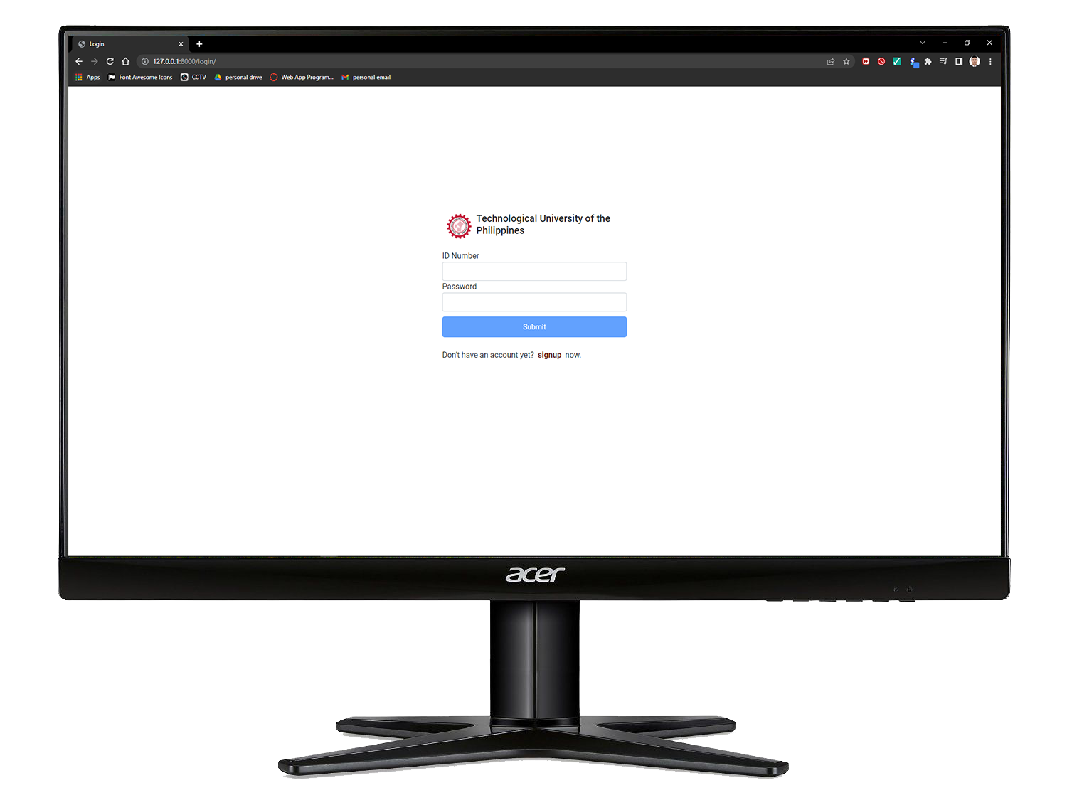

*Figure 22; User Login Page*

Figure 22 shows the Login page of the system. All the users can do is to input their username and password. If their username and password is true they can access the system else if not, there is an error message that will prompt them to re-type again their username and password.

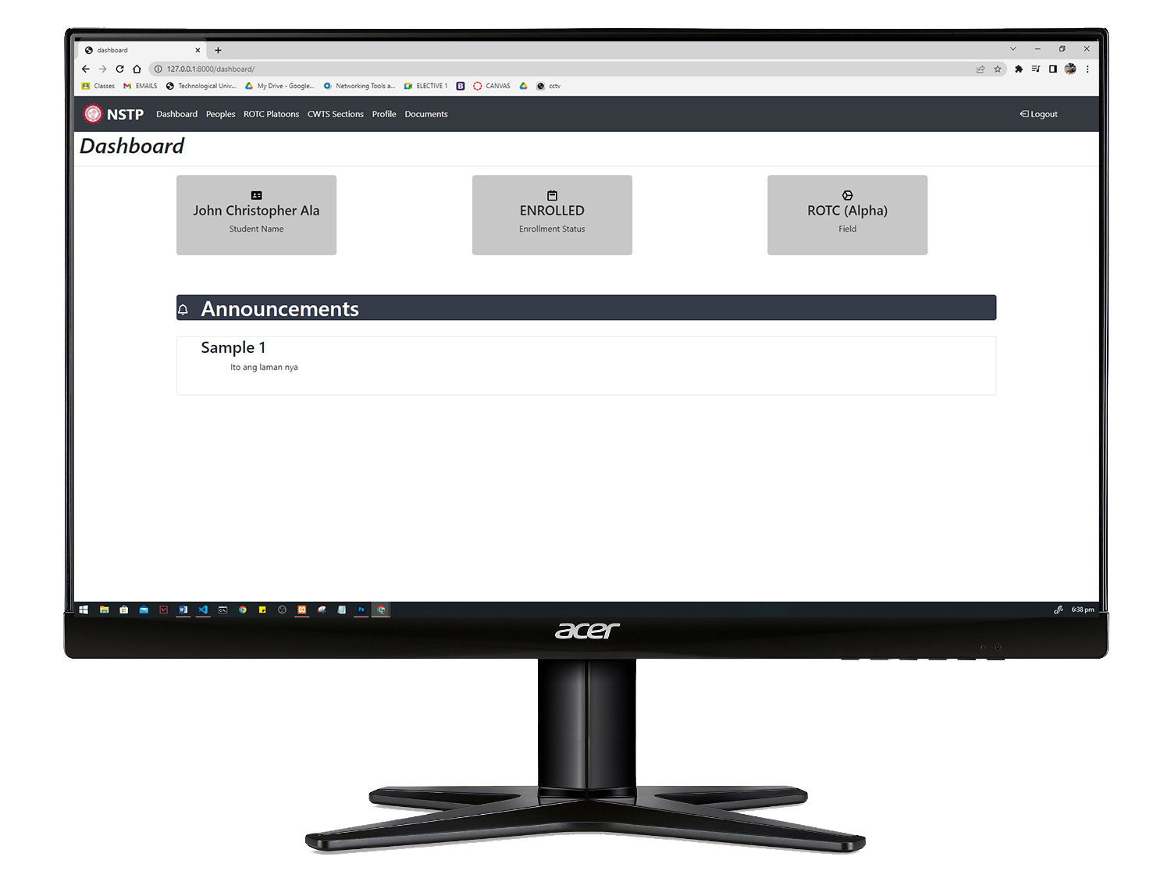

*Figure 23; Student Dashboard*

Figure 23 shows the student dashboard. This is the page where they can see their relevant information like their name, Enrollment status, section or platoon and also the general announcements.

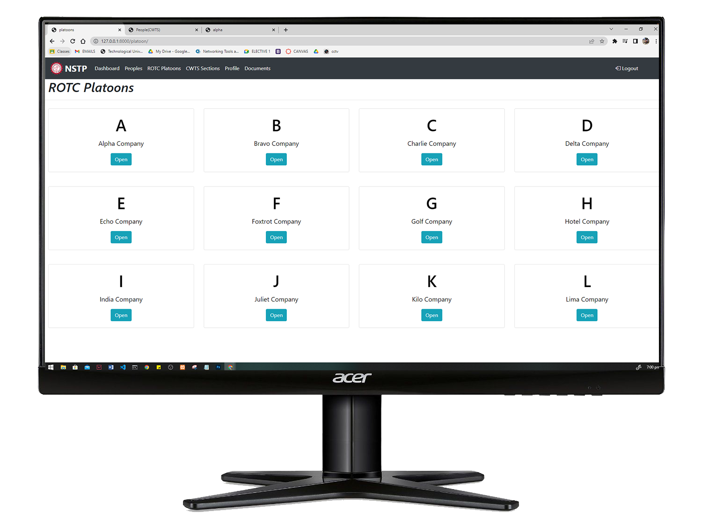

*Figure 24; ROTC Platoons*

Figure 24 shows the Cards of rotc platoons. This is where all files of the lectures have been uploaded after the training day. The Students can download the file for their personal purpose like for review or for sharing to others.

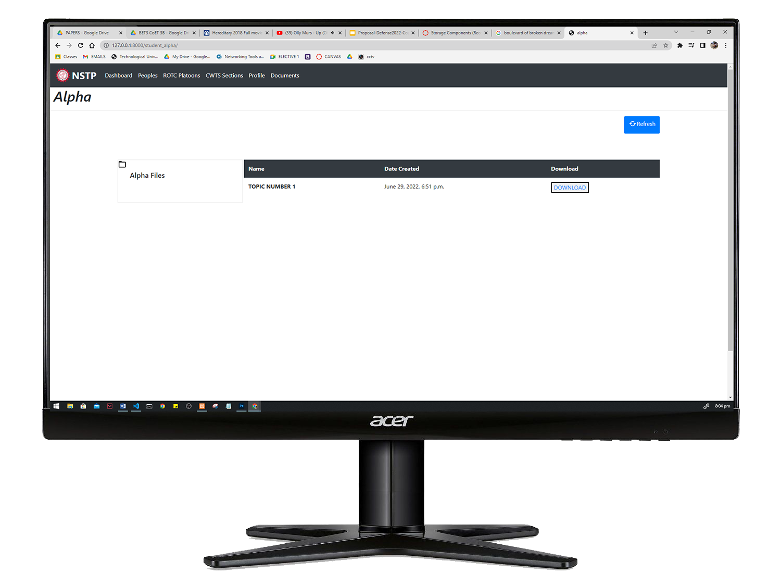`*Figure 25; Platoons FIles*

Figure 25 shows the Interface inside the Platoons. Inside the platoons there are no other contents but just the files. And those files are uploaded by the instructors who manage the designated platoon or sections.

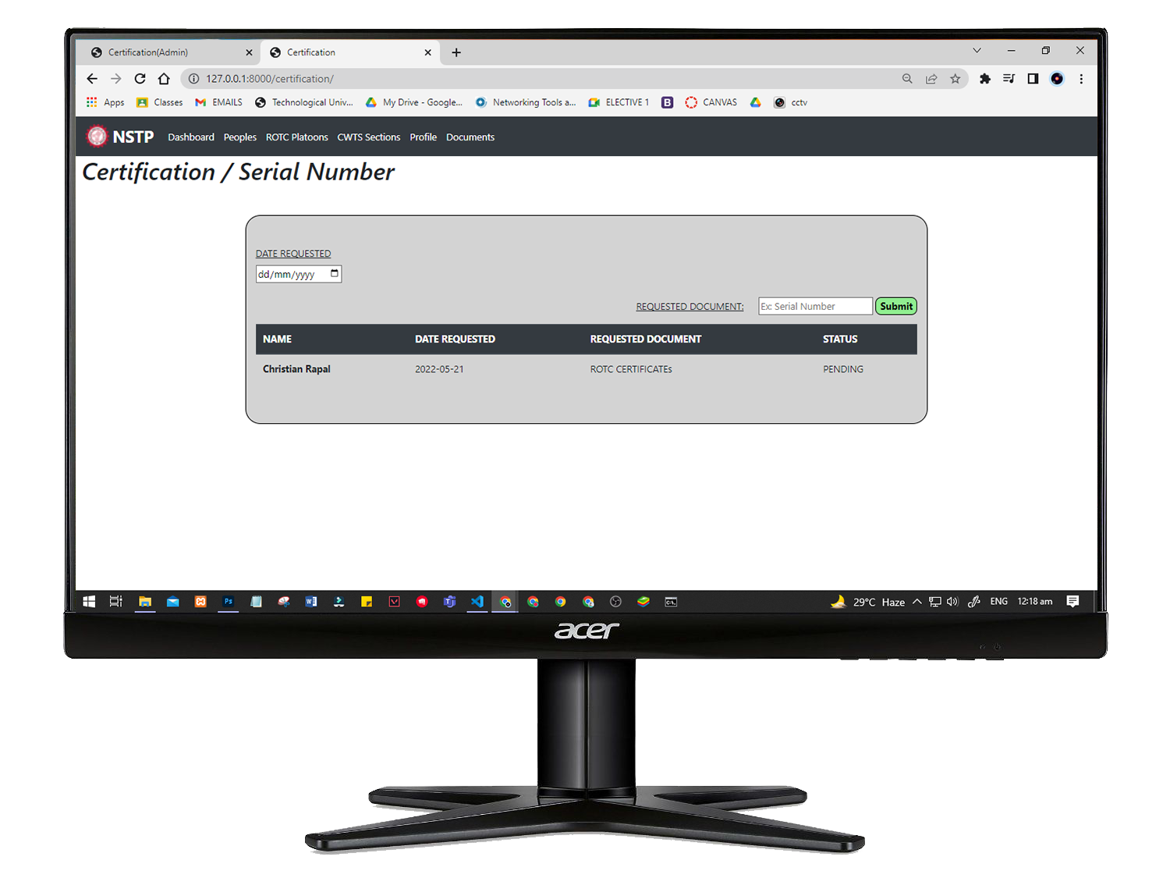

*Figure 26; Student Request Page*

Figure 26 is the draft User Interface(UI) of the proposed system for Requesting of documents. This is where the student will type their Documents needed like Certificate or other papers including serial number, but serial number as of now will be claimed to Fort Bonifacio Taguig., So the possibility of requesting it will be fast but this will be claim to the headquarters of the Philippine Navy Taguig.

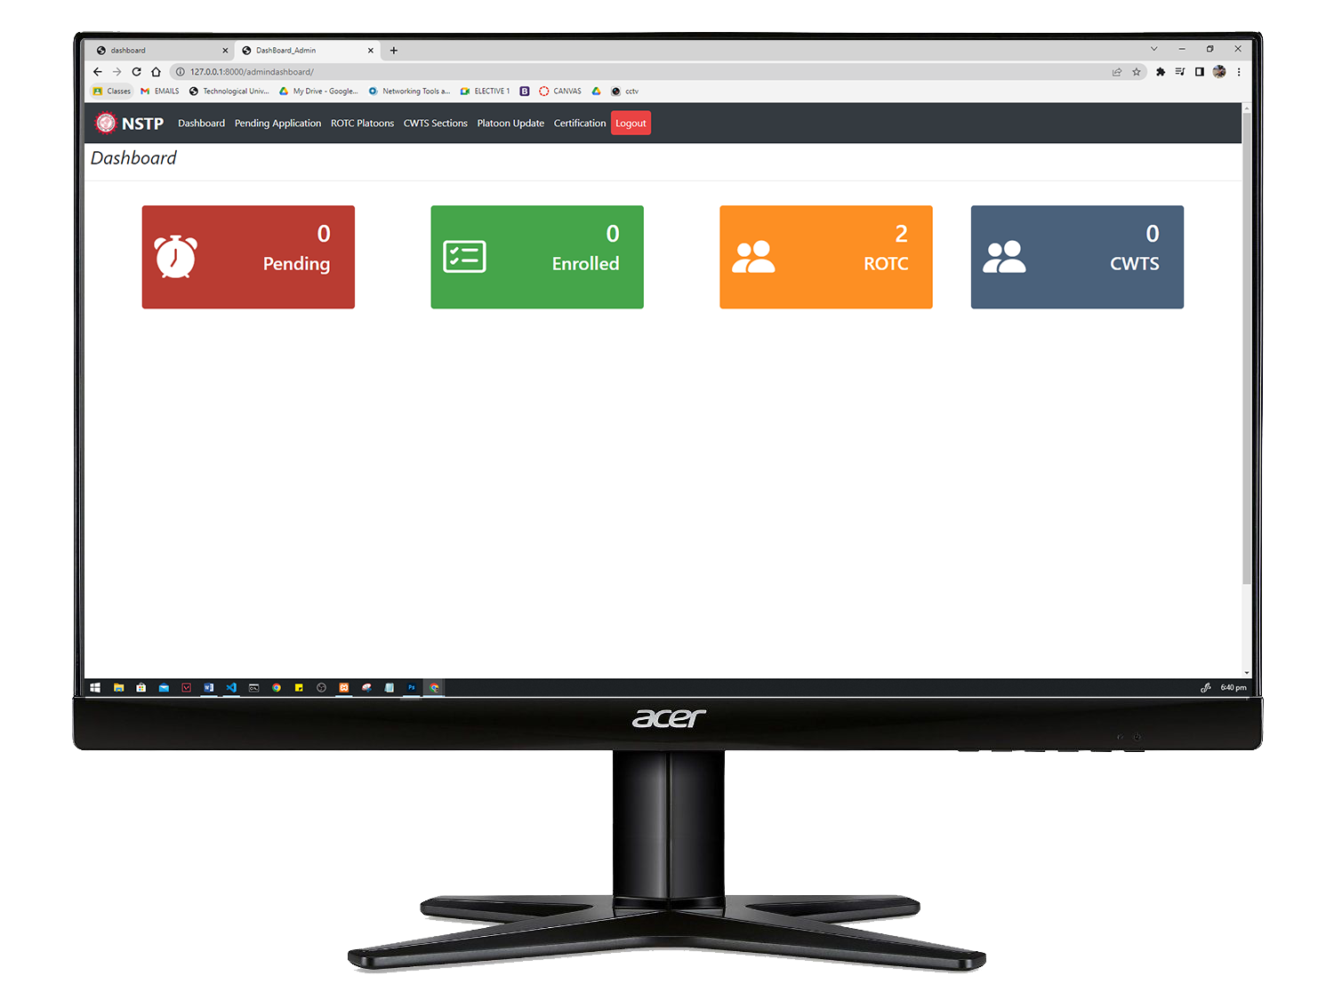

*Figure 27; Admin dashboard*

Figure 27 shows the admin dashboard of the system. This is where the admin will see the count of all students who are taking NSTP. Also the admin or staff will see the count of students inside the platoons and sections of the nstp.

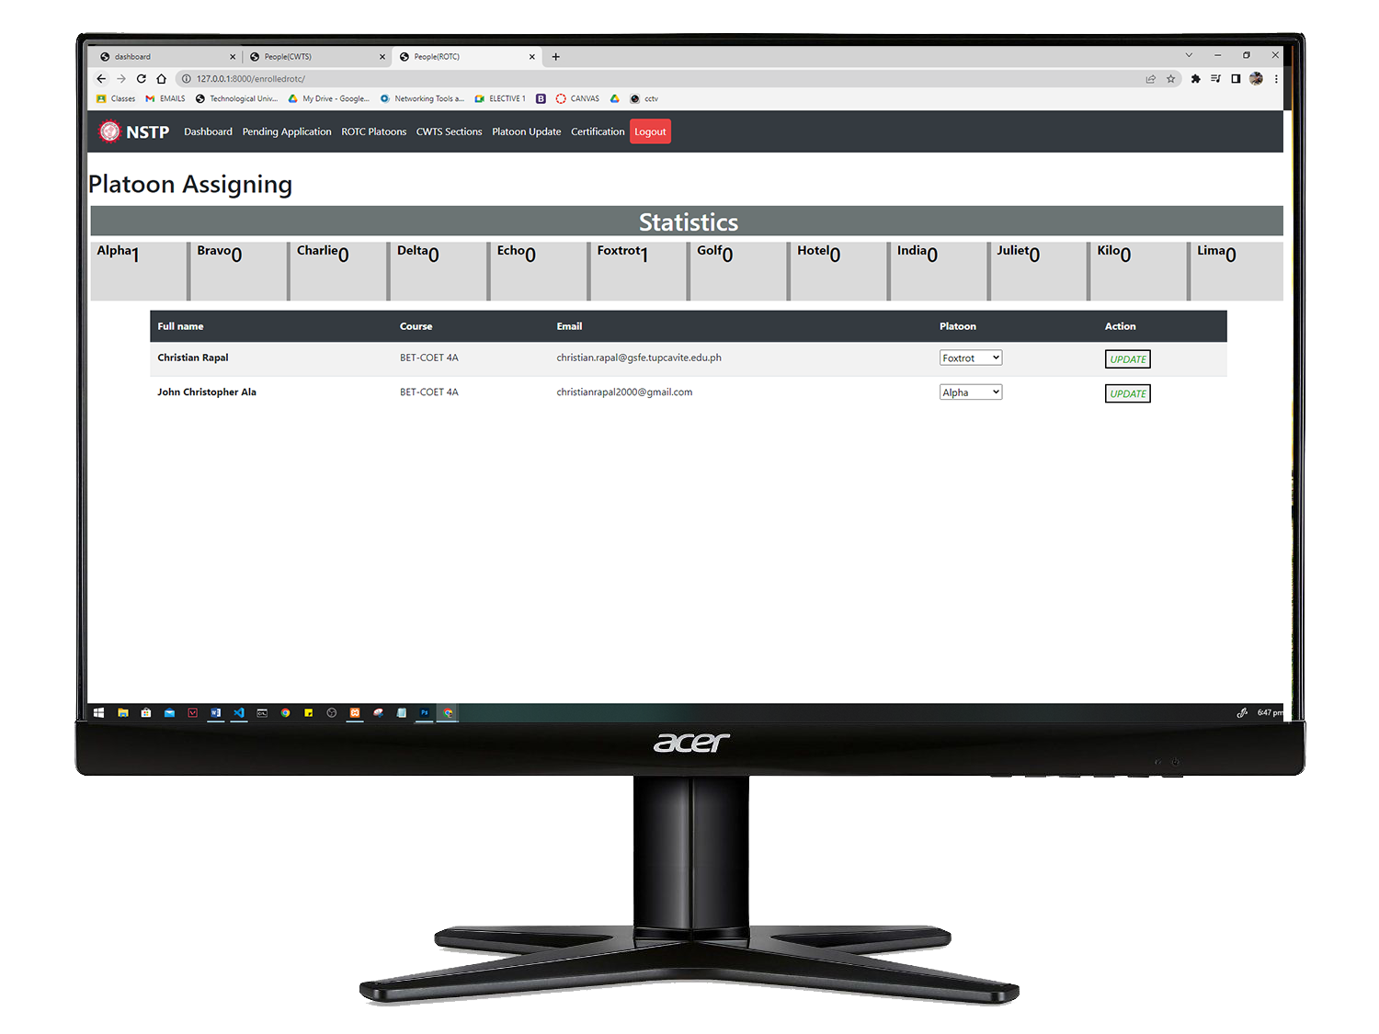

*Figure 28; Admin-platoon Assigning*

Figure 28 shows the User Interface (UI) of admin assigning platoons to enrolled Students. Once the students was assigned, the update will automatically appear on their dashboard.

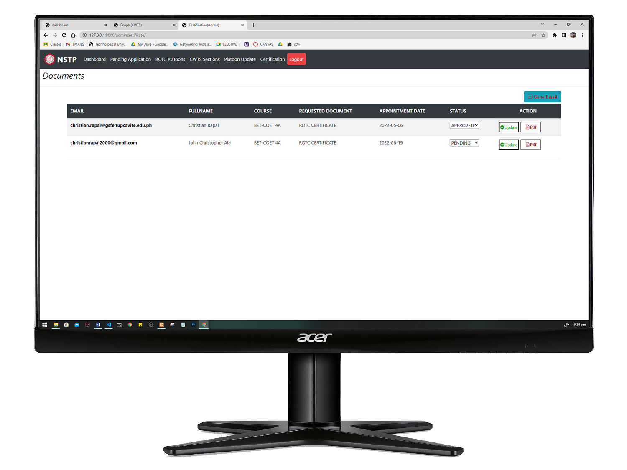

*Figure 29; Admin-Certification*

Figure 29 shows the User Interface (UI) of the admin certification part. This is where the requested certificate of students will be generated. This is the one click generation of certificate that makes it more convenient to staff who will use the system.

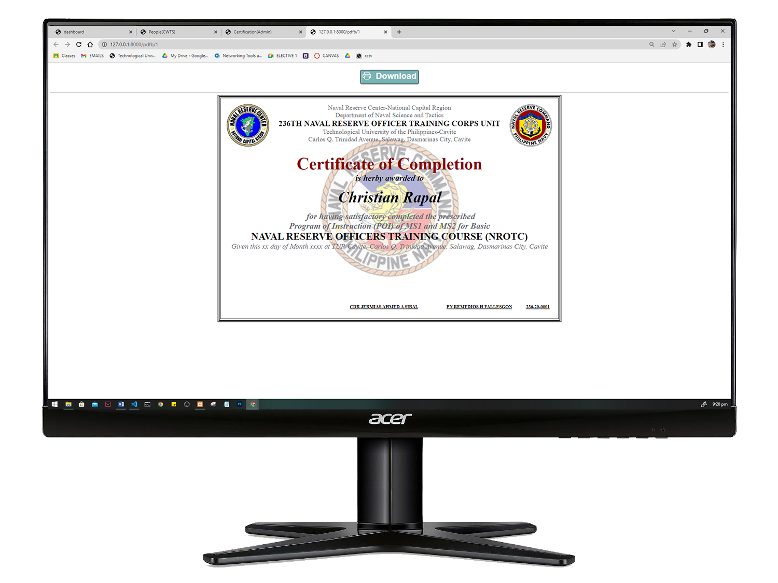

*Figure 30; Certificate Generated*

Figure 30 shows the User Interface (UI) of the admin certification part. This is where the requested certificate of students will be generated. This is the one click generation of certificate that makes it more convenient to staff who will use the system.

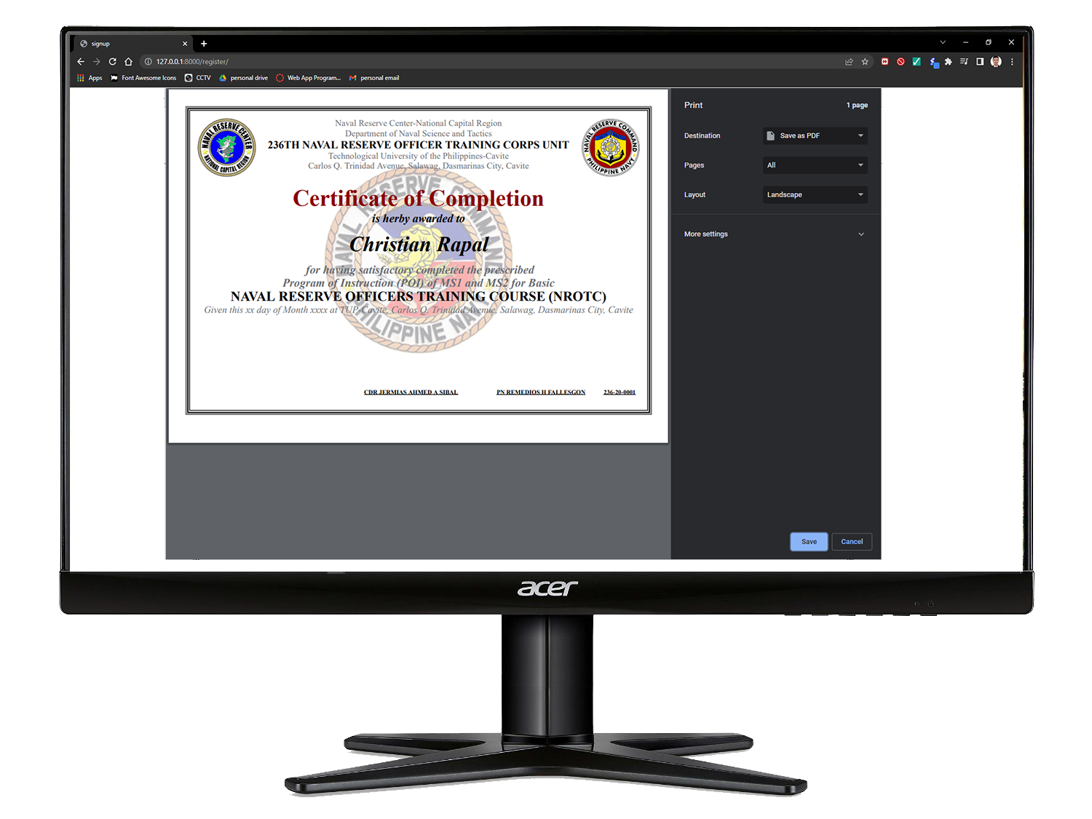

*Figure 31; Certificate Saving / Printing*

Figure 31 shows the Interface of saving or printing of the certificate generated by the system.

**Operation and Testing Procedure**

The following operating method must be followed in order for the NSTP System to run properly.

In testing the NSTP System for TUPC, the researchers manage to create a series of tests to check the functionality, accuracy and reliability. According to

the following conditions:

**Project Test Results:**

**Table No. 1**

*Likert Scale*

| **Numerical Rating** | **Descriptive Rating** |
| --- | --- |
| 5.0 | Excellent/Highly Acceptable |
| 4.0 | Very Good/Very Acceptable |
| 3.0 | Good/Acceptable |
| 2.0 | Fair/Fairly Acceptable |
| 1.0 | Poor/Not Acceptable |

**Table No. 2**

*Descriptive Interpretation of the Medium*

*Table no. 2 shows the numerical rating and the corresponding interpretation rating.*

| **Numerical Scale** | **Statistical Limit** | **Verbal Interpretation** |
| --- | --- | --- |
| 5 | 4.51 - 5.00 | Excellent |
| 4 | 3.51 - 4.50 | Very Good |
| 3 | 2.51 - 3.50 | Good |
| 2 | 1.51 - 2.50 | Fair |
| 1 | 1.00 - 1.50 | Poor |

**Project Test Results**

This shows the following results of the tests conducted in terms of Functionality, Accuracy and Reliability for displaying post wirelessly

The functionality of the NSTP Sytem in the entire system is shown in Table 3 and 4

**Test Procedure for Functionality**

**Table No. 3**

Functionality of Registering, requesting of certificates, of students in Nstp to

| **Test Conducted** | **Expected Output** | **Actual Output**  **Test 1 Test 2 Test 3** |
| --- | --- | --- |
| Browse the system link within the network | System Log-in account will displayed |  |
| Enter all necessary information | Accounts will be successfully registered |  |
| Log-in with valid credentials | User account can access the system |  |
| Submit a request | Request will be displayed at at pending list |  |

*Table 3*

**Table No. 4**

Functionality of Signing in, approving of enrollment, generating of certificates, uploading of files, Archiving of all documents of students in Nstp

| **Test Conducted** | **Expected Output** | **Actual Output**  **Test 1 Test 2 Test 3** |
| --- | --- | --- |
| Browse the system link within the network | System Log-in account will displayed |  |
| Log-in with valid credentials | User account can access the system |  |
| View the pending list or registeration | All students want to register will be displayed |  |
| View the certification list | All request will be displayed |  |
| Choose a files to upload in Nstp | All files uploaded will be displayed |  |
| Archieve all documents | All documuents of the students will be save in archive |  |
| Taking the attendance of students | Names and time in and out of the student will be displayed |  |

*Table 4*

**Test Procedure for Accuracy**

The Accuracy of the NSTPSytem in the entire system is shown in Table 5

**Table No. 5**

| **Test Conducted** | **Expected Output** | **Actual Output**  **Test 1 Test 2 Test 3** |
| --- | --- | --- |
| View the pending list or registration | All students want to register will be displayed |  |
| Generating of certificates | Certificates will be generated with the name of the students |  |
| Taking the attendance of students | Names and time in and out of the student will be displayed |  |

*Table 5*

**Test Procedure for Reliability**

**Table No. 6**

Reliability of Registering, requesting of certificates, of students in Nstp to

| **Test Conducted** | **Expected Output** | **Actual Output**  **Test 1 Test 2 Test 3** |
| --- | --- | --- |
| Log-in invalid user account | The system is not accessible and Error message will be displayed |  |
| Log-in valid user account | The user account can access the system |  |

*Table 6*

**Project Evaluation Results**

**Table No. 7**

Functionality performance of the Nstp System

| **Indicators** | **Mean** |
| --- | --- |
| Ease of operation |  |
| Provision for comfort and convenience |  |
| User friendliness |  |
| Total mean average |  |

**Table No. 8**

Performance of the Nstp System

| **Indicators** | **Mean** |
| --- | --- |
| Color |  |
| Attractiveness |  |
| Appropriate in size |  |
| Total mean average |  |

**Table No. 9**

Workability Performance of theNstp System

| **Indicators** | **Mean** |
| --- | --- |
| - |  |
| - |  |
| - |  |
| - |  |

**CHAPTER 4**

**RESULTS AND DISCUSSION**

This chapter contained the Project Description, Project Capabilities and Limitations and Project Test Results.

**Project Description**

asd

**Project Structure**

Asd

**Project Test Result**

Asdasd

**Project Capabilities and Limitations**

Asdasd

**CHAPTER 5**

**SUMMARY OF FINDINGS, CONCLUSION AND RECOMMENDATIONS**

**Summary of Findings**

Asdasd

**Conclusion**

Asdads

**Recommendations**

asdasd

**References:**

**QR Code**

[Iranna M Shettar](https://www.researchgate.net/profile/Iranna-Shettar-2) (April 2016), *Quick Response (QR) Codes in Libraries: Case study on the use of QR codes in the Central Library, NITK*

<https://www.researchgate.net/publication/301887341_Quick_Response_QR_Codes_in_Libraries_Case_study_on_the_use_of_QR_codes_in_the_Central_Library_NITK>

**BAR Code**

Denso Wave (2022), What is a barcode, https://www.denso-wave.com/en/adcd/fundamental/barcode/barcode/index.html

**Certificate Generator**

Bharti Chikankar, Sidhant Jaiswal (07-09-2020), Certificate Generation System

<https://www.journals.resaim.com/ijresm/article/view/251>

**Web Application**

Indeed Editorial Team(02-26-2020), What is a Web Application

<https://www.indeed.com/career-advice/career-development/what-is-web-application>

**Online Enrollment**

Patrick H. H. Then(November 2006), What is Online Enrollment System

<https://dl.acm.org/doi/10.1145/1181216.1181300>

**Attendance using Qr code Scanner**

[Fadi Almasalha](https://www.researchgate.net/profile/Fadi-Almasalha) (January 2014), [Smart Attendance System](https://www.researchgate.net/project/Smart-Attendance-System): [International Journal of Advanced Computer Science and Applications](https://www.researchgate.net/journal/International-Journal-of-Advanced-Computer-Science-and-Applications-2156-5570)

<https://www.researchgate.net/publication/275605455_A_Students_Attendance_System_Using_QR_Code>

**Html**

[A](https://www.investopedia.com/contributors/53677/)dam Hayes (11-13-2020), What is Html

<https://www.investopedia.com/terms/h/html.asp>

**Database**

**Oracle (2022), What is Database**

<https://www.oracle.com/ph/database/what-is-database/>

**Css**

TechTerms.com (2006), What **is Css**

<https://techterms.com/definition/css>

**Javascript**

[Dillion Megida](https://www.freecodecamp.org/news/author/dillionmegida/) (March 29, 2021), What is JavaScript

<https://www.freecodecamp.org/news/what-is-javascript-definition-of-js/>

**Python Web Framework**

[Omed Habib](https://www.appdynamics.com/blog/author/omed/) (January 25 2016), What is Python Web Framework

<https://www.appdynamics.com/blog/engineering/an-introduction-to-python-frameworks-part-1/>

**Django**

Djangoproject (2005), What is Django

<https://www.djangoproject.com/>

**Xampp**

Apachefriends (2022), What is Xampp

https://www.apachefriends.org/